Commands:

* whoami - Gives login name

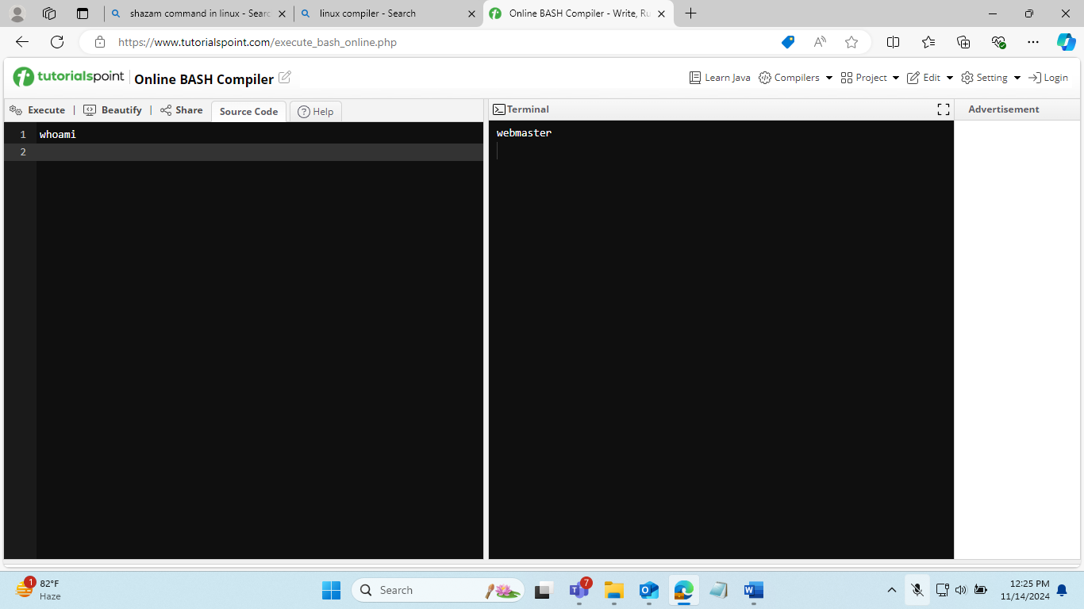

* hostname – Gives name of the computer

* echo “Hello, World” – Prints Hello World

* echo $HOME – print environment variable

* echo my name is $(whoami) – replaces $() with output

* date – prints today date

* cal - prints month’s calendar

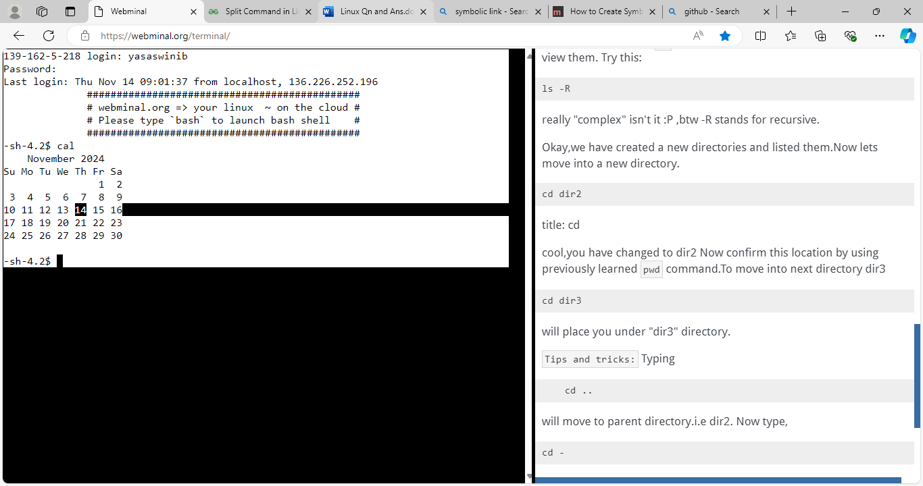

* shazam

Commands: Selected text processing utilities

* awk – Pattern scanning and processing language

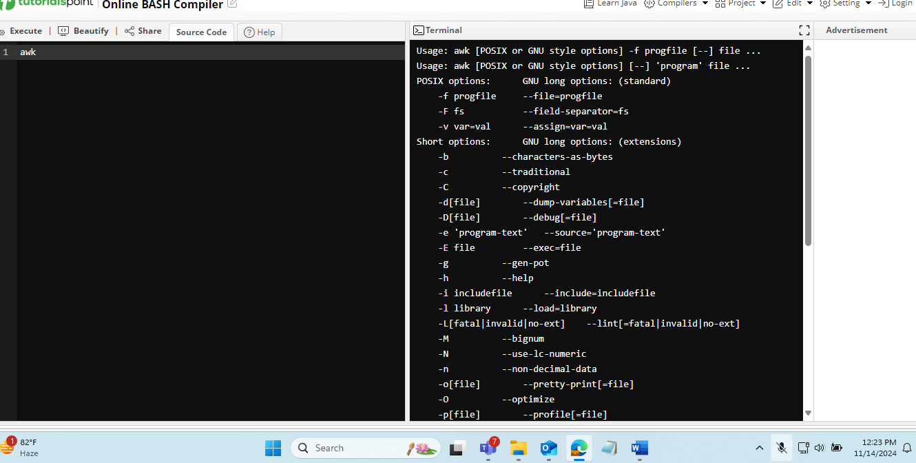

* cat – display files 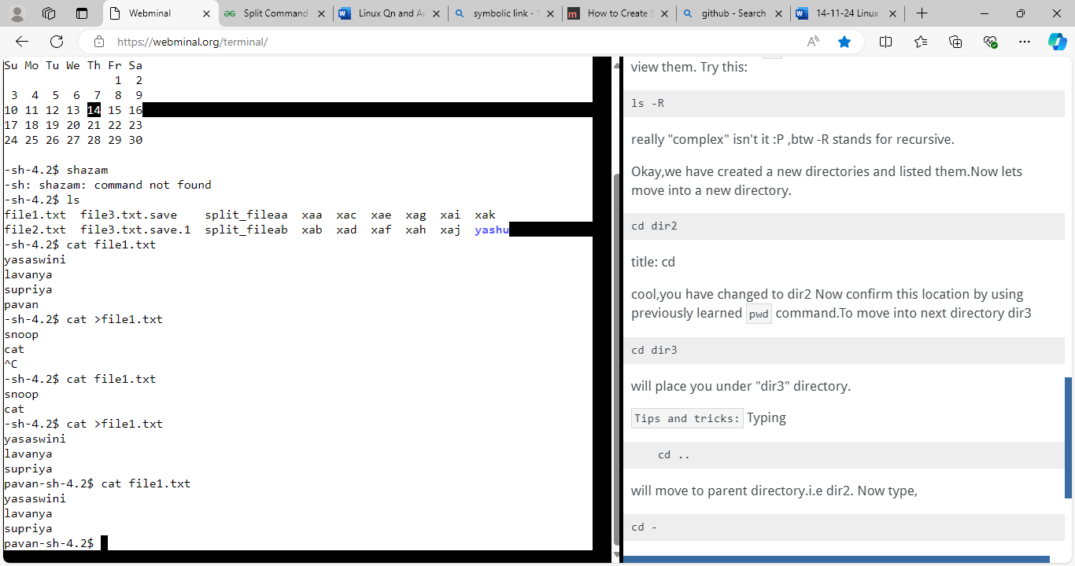
* cut – Extract selected fields of each line of a file

* diff – compare two files

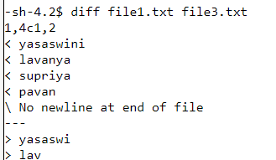

* grep – select text for a pattern



* head – display first part of files

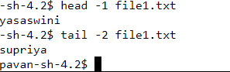

* less – display files on page-by-page basis
* sed – Stream editor

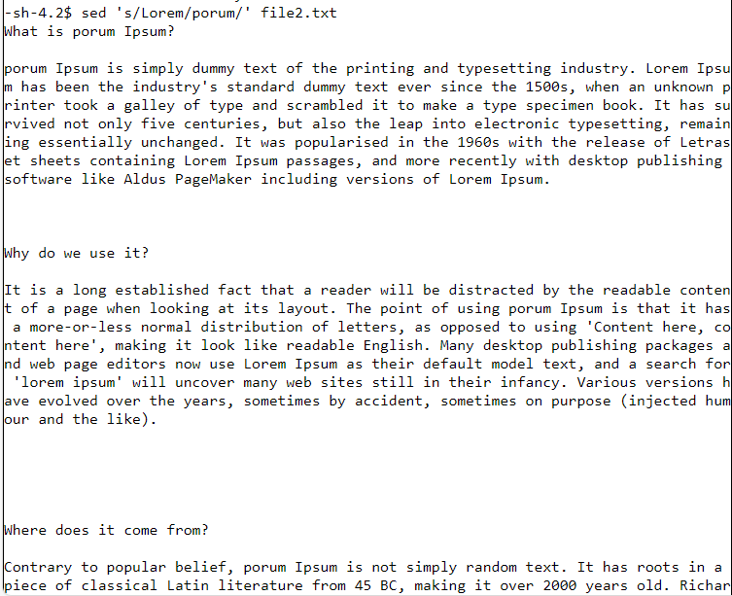

* sort – Sort text files

* split – Split files

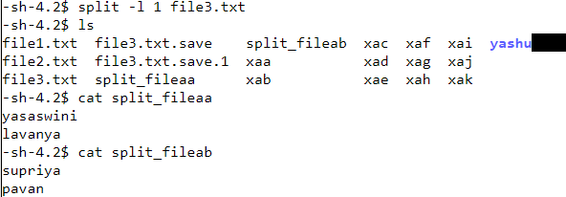

* tail – Display last part of a file

* tr – Translate/delete characters



* uniq – Filter out replaced lines in a file
* wc – Line, word, character count



Move:

Remove:

Copy:

